**Native Voice Alert System for Blind Navigation: Utilizing Ultrasonic Sensor HCSR04 with ISD1820 and Arduino nano**

Kartheeswari M Pooran Selvi M Suriyakala N

**Abstract**

This project introduces a Native Voice Alert System for blind navigation, integrating an Ultrasonic Sensor (HCSR04), ISD1820 voice module, and Arduino microcontroller. The system offers real-time obstacle detection and auditory alerts in a native voice format. By leveraging distance measurement capabilities and native voice feedback, it aids blind individuals in navigating their environment safely. The primary goal is to enhance autonomy and safety during navigation for the visually impaired. Keywords: Blind navigation, Ultrasonic sensor, HCSR04, ISD1820, Arduino, Voice alert system, Native voice, Obstacle detection, Assistive technology.

**Keywords**: Blind navigation, Ultrasonic sensor, HCSR04, ISD1820, Arduino, Voice alert system, Native voice, Obstacle detection, Assistive technology.

**Circuit Design:**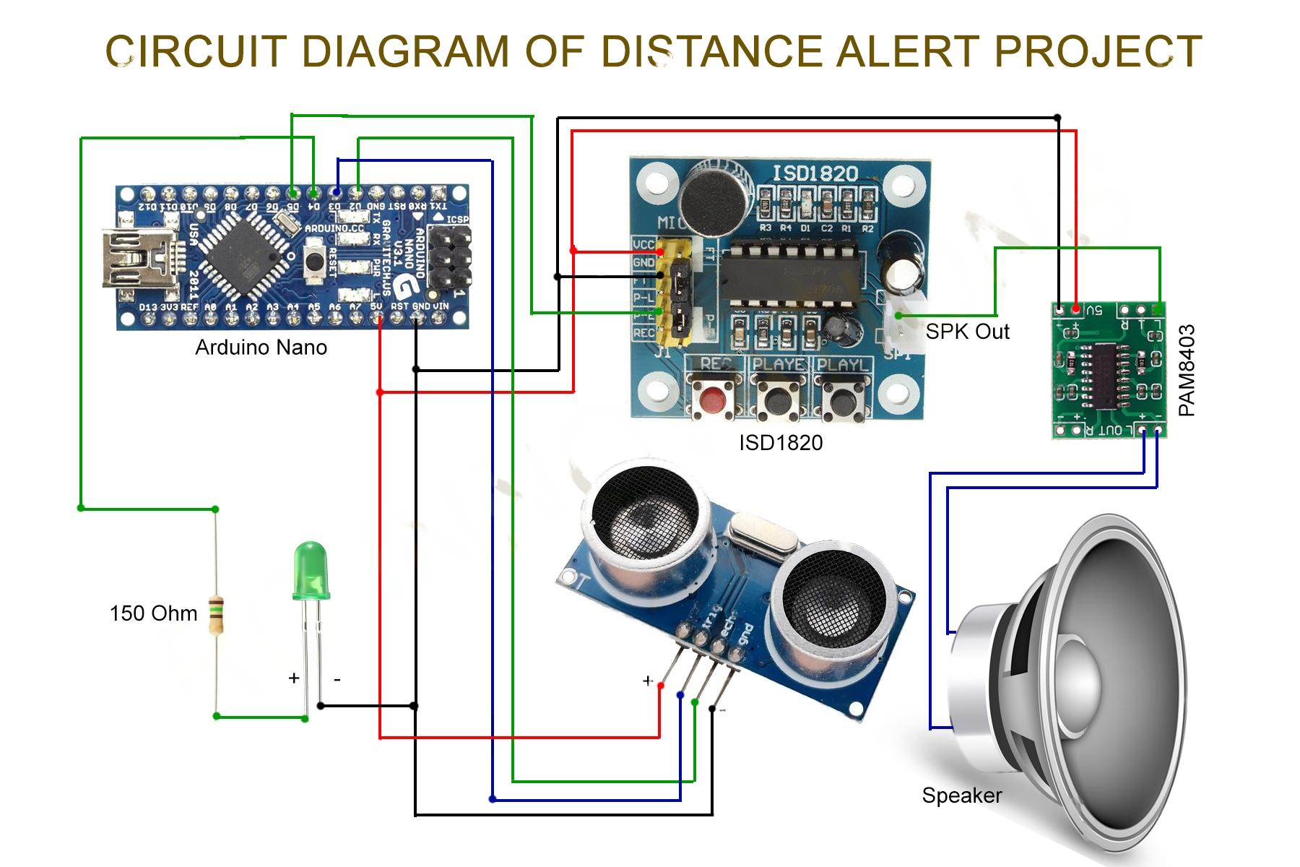

**Source code:**

// Native Voice Alert System for Blind Navigation: Utilizing Ultrasonic Sensor HCSR04 with ISD1820 and Arduino nano

// by RG Innovations

// This sketch can work with ATtiny85 and Arduino UNO, MEGA, etc...

// This example code is in the public domain.

#define trigPin 3 //HCSR05 Trigger set to pin 3

#define echoPin 2 // HCSR05 Echo set to Pin 5

#define LED_PIN 4 // LED light set to Pin 4

#define ISD_PIN 5 // ISD1820 module PE Pin

#define DISTANCE 10 // Distance value to check in CM

long duration, cm;

void setup()

{

  pinMode(LED_PIN, OUTPUT);

  pinMode(trigPin, OUTPUT);

  pinMode(echoPin, INPUT);

  digitalWrite(LED_PIN, LOW);

}

void loop()

{

  //sending the trigger pulse, starting with LOW for a clean pulse

digitalWrite(trigPin, LOW);

delayMicroseconds(2);

digitalWrite(trigPin, HIGH);

delayMicroseconds(10);

digitalWrite(trigPin, LOW);

//setting up the input pin, and receiving the duration in uS

pinMode(echoPin, INPUT);

duration = pulseIn(echoPin, HIGH);

// convert the pulse travel time into a distance

cm = microsecondsToCentimeters(duration);

      if (cm<=DISTANCE){

        digitalWrite(LED_PIN, HIGH);

        digitalWrite(ISD_PIN, HIGH);

        delay (200);

        digitalWrite(ISD_PIN, LOW);

        delay (4800);

        digitalWrite(LED_PIN, LOW);

      }

delay(100);

}

long microsecondsToCentimeters(long microseconds)

{

// The speed of sound is 340 m/s (29 us/cm)

return microseconds / 29 / 2;

}

**Demonstration video:**

<https://youtube.com/shorts/xWqyjSv5XnA?feature=share>

**Conclusion:**

In conclusion, the development of the Native Voice Alert System represents a significant step forward in assistive technology for blind navigation. By seamlessly integrating ultrasonic sensing with native voice feedback, the system provides real-time obstacle detection and enhances the safety and autonomy of visually impaired individuals. Through our experimentation and testing, we have demonstrated the system's effectiveness in aiding navigation and its potential to positively impact the lives of blind users. Further refinements and optimizations can be made to improve accuracy and usability, paving the way for wider adoption and integration into assistive devices for the visually impaired.